National University of Computer and Emerging Sciences



Peshawar Campus

Name: Sahil Anwar
Roll Number: 22P-9141
Section: BSSE-1A
Subject: PF Lab Task: 07

Task 07
Question 1
Part (a)
#include<stdio.h>
int main()
{
int i,j,k,rows=5;

for ( i=0; i<rows; i++)
{
for ( j=0; j<i; j++)
{
printf(" ");
}
for ( k = rows; k > i; k-- )
{
printf("*");
}
printf("\n");
}
return 0;
}

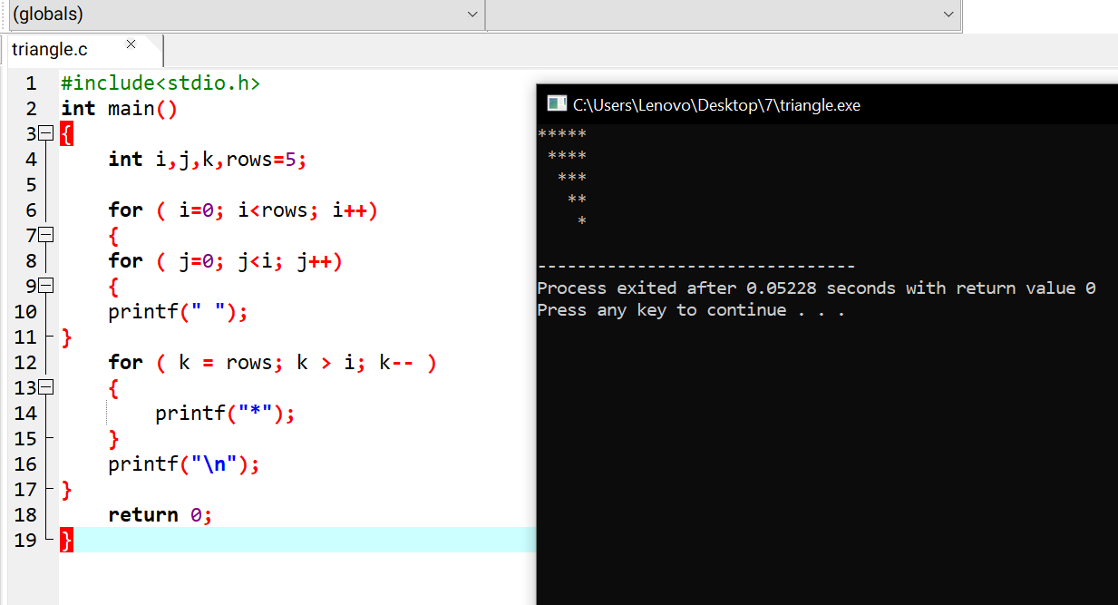

Part (b)
#include<stdio.h>
int main()
{
int i,j,k,rows=5;

for ( i=0; i<=rows; i++)
{
for ( j=rows; j>i; j--)
{
printf(" ");
}
for ( k =0; k < i; k++ )
{
printf("*");
}
printf("\n");
}
return 0;
}

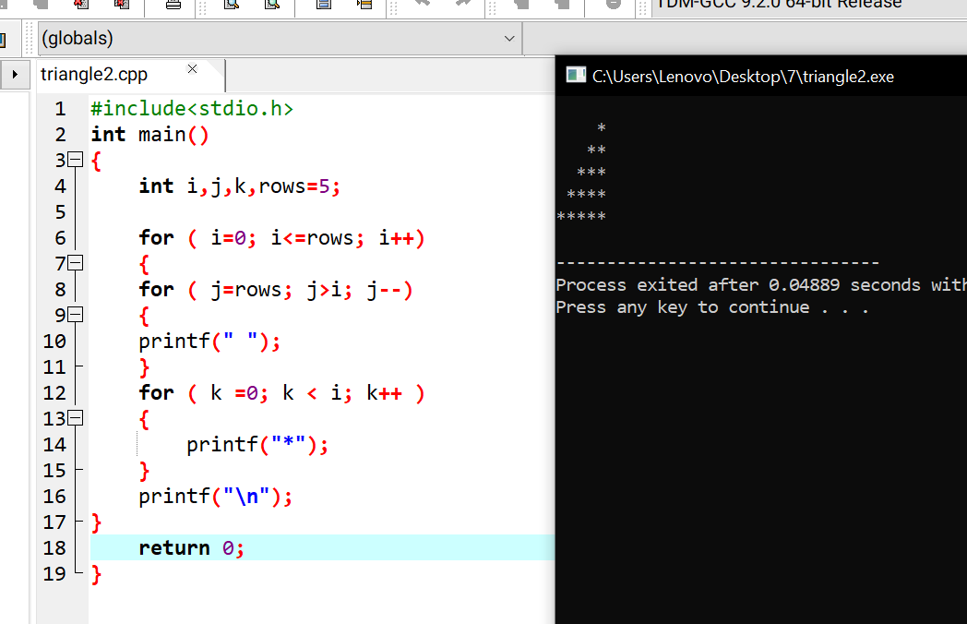

Question 2
#include <stdio.h>
int main()
{
char s;
printf("Enter the symbol\n");
scanf("%c", &s);
for (int i = 1; i <= 5; i++)
{
for (int j = 1; j <= i; j++)
{
printf("%c ", s);
}
printf("\n");
}
for (int i = 4; i > 0; --i)
{
for (int k = 1; k <= i; k++)
{
printf("%c ", s);
}
printf("\n");

}
return 0;
}

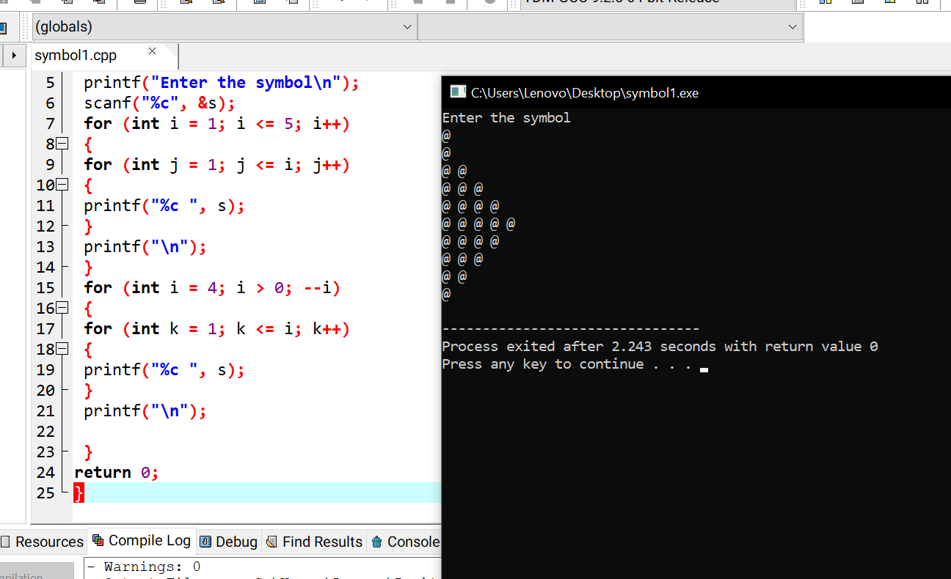

Question 3
#include<stdio.h>

int fact(int z);
int power(int p, int z);
float total(int y, int z);

int main()
{

int z, y;
printf("Enter the value of y:");
scanf("%d",&y);
printf("Enter the value of z:");
scanf("%d",&z);

printf("%f\z",total(y,z));

return 0;
}

int fact(int z)
{
int a=1;
for(int i=1;i<=z;i++)
{
if(z==0)
a=1;
a*=i;
}
return a;
}

int power(int p, int z)
{
int a=1;
for(int i=0;i<z;i++)
a*=p;
return a;
}

float total(int y, int z)
{
float a=1,b;
for(int i=1;i<=z;i++)
{
b=(float)power(y,i)/fact(i);
a=a+b;
}
return a;
}
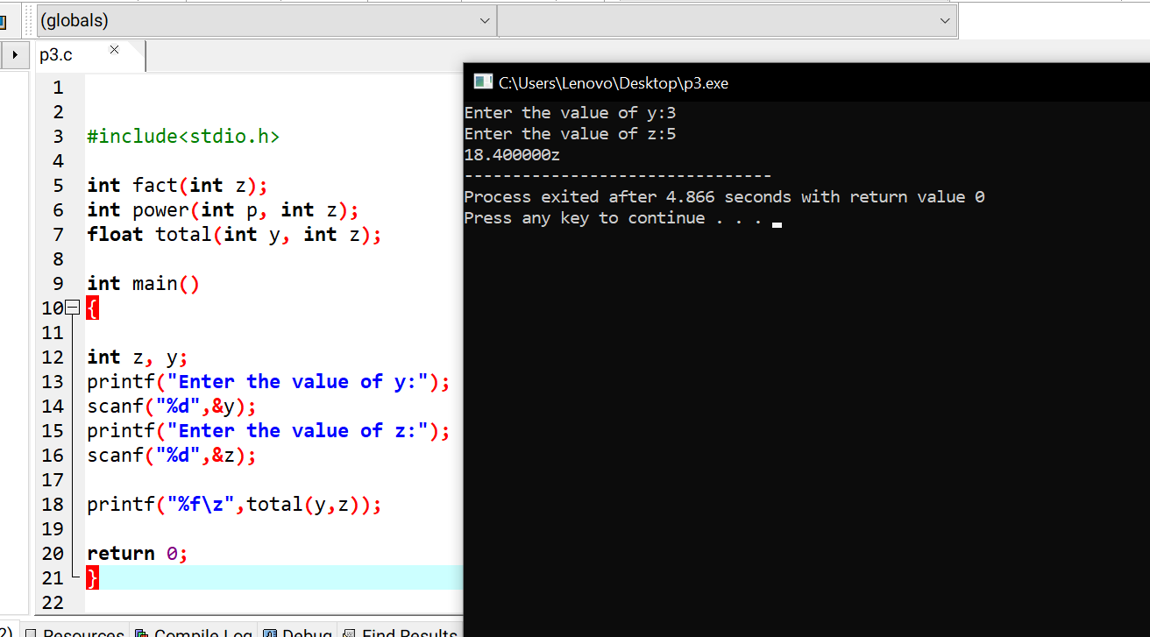

Question 4

#include <stdio.h>
int main()
{
int n=1, rem, s,c=0;

for (int k = 1; k >0; k++)
{
s = 0;

for (int i = 1; i <= n/2; i++)
{
rem = n % i;
if (rem == 0)
{

s = s + i;
}
}
if (s == n)
{
c++;
printf(" %d is a Perfect Divisible or Perfect NUmber\n", n);

if (c == 4)
{
break;
}
}
n++;
}
return 0;
}
